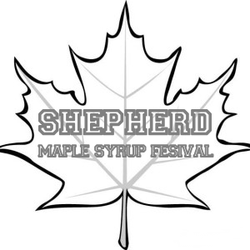

**Shepherd Maple Syrup Festival Media Release Form**

I understand the photograph(s) or video or audio recording(s) taken of my child by agents, volunteers or representatives of the Shepherd Maple Syrup Festival (hereinafter called “SMSF”) shall, in any manner or any medium, be used for the purpose of publication, promotion, illustration, or advertising the SMSF.

I hereby irrevocably authorize the SMSF to copy, exhibit, publish or distribute any and all such images and audio of my child or wherein he or she shall appear, including composite or artistic forms and media, for purposes of publicizing SMSF events or for any other lawful purpose. In addition, I waive any right to inspect or approve the finished product, including written copy, wherein my child’s likeness appears.

I hereby hold harmless and release and forever discharge the SMSF from all claims, demands and causes of action which I, my heirs, representatives, executors, administrators and any other persons acting on my or my child’s behalf, may have by reason of this authorization.

Child’s Legal Name (Please print) Birth Date

I hereby certify that I am the parent or guardian of, the minor named above, and do hereby give my consent without reservations to the abovementioned.

Parent/Legal Guardian Signature Date

Printed Name